**World Exercise**

Download the world database SQL script here: [MySQL world database](http://downloads.mysql.com/docs/world.sql.gz)

Run the SQL script and you should have 3 tables in the world database: city, country and countrylanguage. The schema of the world database is as follows:

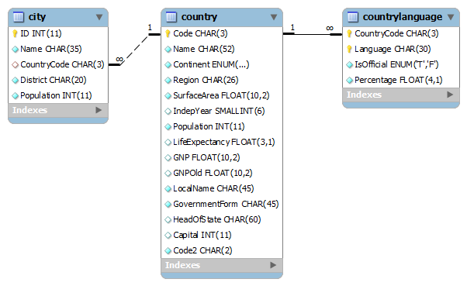

Using SQL, find out the following:

1. Return the country names that have English as their official language.
2. Count how many countries there are in the Antarctica region.
3. Return the top 5 cities with the most population.
4. Return the top 10 countries with the least life expectancy.
5. Return the top 5 districts with the most population.
6. Return the languages that have 50% or more of the population speak it in their respective countries.
7. Return the region with the highest average GNP.
8. Return the continent with the highest population density. (Hint: Population density = population/surface area)
9. Count how many countries speak French.
10. Return the countries which have their year of independence at 1950 or later.